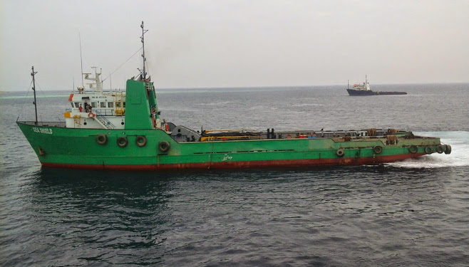

AHTS “Sea SHIELD” 4,600 B.H.P
Main Particulars | Principal Dimensions
Built: 1983  Call Sign: S.S.DH  Flag: Egyptian  Port of Registry: port said  Class: A.B.S. - A.H.T.S  Owners: Ships and Boats  X owner Maridive Oil Services | Length Overall: 192.5 FT i.e58.7 M  Lengthb.p: 178 FT i.e 55.2M  Beam: 40.F0 T .12.2M  Maximum Draft: 12.8 FT. 3.9 M  Gross Tonnage: 1664.00 tons
Main Engines: | Anchor Handling / Towing Winch :
2EMID 12 – 645 – E7BA, Continuous 4610 BHP  2 Fixed pitch propellers.  Auxiliaries:  2 – GM 8V 71,250 KW 110/220/440 VAC 60 HZ 1 – GM8 V 71  Bow Thruster unit:1 – GM871,300HP,4.1 Ton thrust | Combined two drum heavy duty anchor handling & towing winchSMATCO 72 DAW – 250, Double-drum, Water fall type 253,120 Ibs.  Tow wire ……….. 1000m/50mm  Spare wire ……… 1000m/50mm  - Winch:one hydraulic winch ,5tons  - Model SMATCO 72 DAW  - Line Pull 253,120lbs,single line pull  - Capstan:(2) Hydraulic Braatvaag  - Stern Roller:5 ft Diameter/ 8 ft Wide  - TowPins(2) Hydraulic  2500’ – 2 1/4ABS galv.  Work wire ……… 250 ’ – 2 1/4ABS galv.
Cargo Capacities | Navigational Equipment
Deadweight: 1,052M Ton  Clear Deck Area: 122f tX32 ft I 37.2X9.8mPotableWater: 288m3  Fuel Oil: 388 m3  Portable Water: 288m 3  Bulk cement/Barite:141 cu. M  Liquid mud 230 cu m  Drill water/Ballast 626 m3  Walk-In Cooler: 280 Cu.ft at +5eC  DeckStrength:5.0 t/m2  Minimum Weight:20.0 m  Displacement Load Line: 1,844M Ton  Cargo winch:  One hydraulic winch, 5 Tons. | Radar(s): Decca RM 914 - C+ Furumo FS 1562  Radio(s): Sailor RT 144 AC  SSB - with encoder Stevens 106-1  Gyro Compass:Sperry MK 37  Fathometer:860/2650  Auto Pilot:Sperry 8T  Depth recorder:Furunon and Kodiak
Tow and Anchor Handling | Performance
- Winch:onehydraulic winch ,5tons  - Model SMATCO 72 DAW  - Line Pull 253,120lbs,single line pull  - Capstan:(2) Hydraulic Braatvaag  - Stern Roller:5 ft Diameter/ 8 ft Wide  - TowPins(2) Hydraulian  - Pilican Hook, Alpha Type German Made | Fuel: 90 cu.m/hr @ 55 M head  Potable Water: 90 cu.m/hr @ 55 M head  Drill Water:90 cu.m/hr @ 55 M head  Bulk Cement: 30 cu.m/hr @ 40 M head  Barite : 30 cu.m/hr @ 40 M head  Liquid Mud: 120 cu.m/hr @ 6 bar  Bollard Pull: 52Tst , 52.0T Dyn  Cargo Water: 288m3 @ 246 ft 99.9 t/h @ 75.0 m  Fuel Oil : 388m3 @ 246 ft 99.9 t/h @ 75.0m
Fire Fighting System:

¾ FiFi 1-Four fire monitors – 4 x 450 cu.m/hr. 1800 cu.m/hr.
Foam tanks capacity 15.6 cu.m

Anti – Pollution Equipment :
Two booms with nozzles, one on each side. 8m long Tank : 15.6 cu m.

